**Educational Objective:**

The objective of this lab introduce a diode, study it’s non-linear attributes and then consider models that linearize the diode.

**Pre-Laboratory:**

1. Read chapter 1 and pay special attention to section 1.9 of ***Boylestad “Electronic Devices and Circuit Theory”.***
2. Read and completely understand the entire procedure portion of this laboratory.
3. In Figure 1 complete the table and make a plot of current (I) versus voltage (V) for a 1K resistor.

|  |  |  |  |  |  |  |  |  |  |  |  |  |  |  |  |  |  |  |  |  |
| --- | --- | --- | --- | --- | --- | --- | --- | --- | --- | --- | --- | --- | --- | --- | --- | --- | --- | --- | --- | --- |
| |  |  | | --- | --- | | V (volts) | I (mA) | | -1.50 |  | | -1.00 |  | | -0.50 |  | | 0.00 |  | | 0.50 |  | | 1.00 |  | | 1.50 |  | | 2.00 |  | | 2.50 |  | |
| Resistor, Current versus Voltage |

Figure 1

Note that the plot is ***linear*** – a straight line. Furthermore, 1/R is the slope when voltage is on the x-axis and current is on the y-axis. The x-axis is always the control variable. Since Voltage is easily controlled voltage is often plotted on the x-axis.

BACKGROUND FOR THE NEXT SECTION: In this lab you will study diodes. You are probably already familiar with one type of diode called an LED (light emitting diode). You will be introduced to all kinds of diodes in class and learn that there are two major regions of operation. The first is called the forward bias region where the diode voltage and current are positive. The diode curve in Figure 2 shows the forward bias region. For an LED this is the region that produces light.

The second region is called the reverse bias region where the diode voltage is negative and very little current flows. An LED does not produce any light in this region. Photo-diodes are generally used in the reverse bias region. When light strikes a photo-diode there is a change in reverse current that can be detected with an amplifier.

If you look at the diode curve in Figure 2 you should see that it is not linear. The relationship between current and voltage in a diode turns out to be exponential, NOT LINEAR.

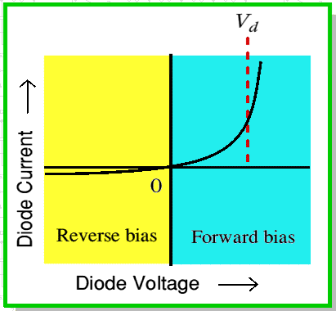

Figure 2

Most programs in electrical or computer engineering technology have students spend a full year studying techniques for analyzing ***linear*** circuits where they learn superposition, Thevenin’ s theorem, mesh, nodal and many others. To use these techniques, the diode is often “*linearized*”. There are many ways (models) to linearize a diode that you will learn about in class. One of these models is a “piece-wise ***linear*** model” where the curve is broken into several straight lines pieces. The idea is to break an exponential curve into a bunch of straight lines. Figure 3 shows a ***linear*** model of the diode. You will learn about each of the regions in class and we will use them in lab as well. In this lab we will focus the On resistance shown on the right side of the graph. The On resistance is also called the “ac resistance” (rac) of a diode where the slope is 1/rac. The ac resistance of a diode is a very important parameter in amplifier design.

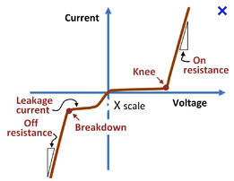

Figure 3

**Procedure:**

1. Complete the pre-lab quiz in lab. This quiz will only be available for the first ten (10) minutes of your laboratory session. The content of this quiz is based on the knowledge you should have gained while completing the pre-lab section of this laboratory activity. You may use your pre-lab as a reference while taking the quiz.
2. *Forward-Biased*:

|  |
| --- |
|  |
| Diode Circuit |

Figure 4

* 1. Build the circuit in Figure 4. Use the function generator in series with the DC power supply to power the circuit.
  2. Set the function generator (VSIN) to 500 mV pk-pk at 1KHz.
  3. Set the power supply (VDC) to 1V.
  4. Verify the supply voltage. Use the follow scope settings:
     + Place CH1 on the left of the diode so it measures VDC + VSIN with the ground clip on the function generator ground.

NOTE: The DC power supply negative should be connected to the positive terminal of the function generator.

* + - Push the **1** Key and select **DC Coupling** using the soft keys on the screen.
    - Verify the MEAN is 1V. Use instructions in below if you need them.
      1. Select **1** as source
      2. Push the **Type** and select **Avg-FS**.
      3. Push **Add Measurement**.
    - The signal may be full of noise and jump around the screen. Small signals are difficult to work with but are part of the real world. To help stabilize the waveform do the following:
      1. Push the **Trigger** button.
      2. Push the **HF Reject** does not use noise when triggering.
    - Verify the frequency is 1KHz. Use instructions in below.
      1. Method 1: quick and easy but jumps around a lot with small signals.
         1. Push the **MEAS** key.
         2. Press **Clear Meas** and clear all measurements.
         3. Push the **Type** and select frequency.
      2. Method 2: better for small signals (when method 1 fails)
         1. Press the **CURSOR** button on the scope.
         2. Use Units on the screen and select **X Units Hz (1/s)**.
         3. Adjust the position of the cursor by turning the knob near the cursor button. The cursor should be positioned at a point where the waveform crosses the horizontal axis.
         4. Press the **Cursors** screen button to activate X2. Adjust the position of the cursor by turning the cursor knob. The cursor should be positioned at an identical point on the waveform one cycle away (horizontally)
         5. The time measured between the two cursors is displayed as “:X” in frequency.
    - Verify the PK-PK is 500 mV. Use instructions in below if you need them.
      1. Method 1: quick and easy but jumps around a lot with small signals.
         1. Push the **MEAS** key.
         2. Push the **Type** screen key and select Pk-Pk.
    - Push the **Clear Measurement** screen key and clear the measures.
  1. Sketch VSIN + VDC in Figure 5 with clearly labeled pk-pk, mean and frequency.

|  |
| --- |
|  |
| Sine Wave with DC Offset |

Figure 5

* 1. Obtain a sign-off for the above completed work (at end of lab).

NOTES ABOUT HOW POWER SUPPLY AND FUNCTION GENERATOR SUPPLIES EACH AFFECT DIODE: Both supplies play an important role in determining the ac resistance of the diode.

VDC turns on the diode “biasing” the diode in the first quadrant (forward bias). Look at the left curve in Figure 6. VDC is used to provide this positive voltage and current. Again, VDC forward biases the diode. The point on the curve established by VDC (VD, ID) is called the quiescent point or Q point.

Notice that VSIN is smaller in magnitude than VDC (100mV, not 1V). VSIN creates a VERY small change in voltage VD. Look at the right curve in Figure 6. You will learn in class that a diodes forward voltage (VD) does not change much once the curve starts to rise. The curve is exponential so small changes in x (VD) make large changes in y (ID).VSIN causes us to move back and forth away from the Q point by VD and ID. Measuring VD and ID we can calculate the ac resistance of the diode.

NOTE: VD is hard to measure because it is so small. Your scope skills will be improved as you learn to measure this very signal. Often sensors produce small signals that must be measured so these skills will be useful.

When the piece-wise linear model for a diode is created the ac resistance is used for the slope of the “on resistance” portion of Figure 3. It is important to note that the actual diode curve is exponential so the value of “on resistance” is highly dependent on the point you pick on the curve or put differently the ac resistance is dependent on the Q point.

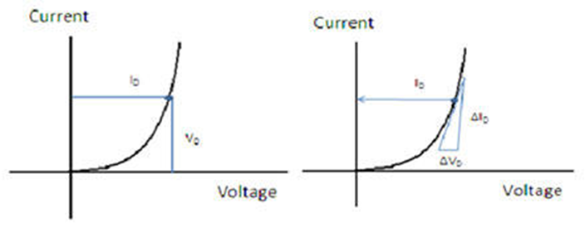

Figure 6

1. *AC resistance*:
   1. Place CH**2** on the right side of the diode so it measures VR.
   2. IMPORTANT STEP: Set the scope coupling on both CH1 and CH2 to **AC Coupling**. (Found by pressing **1** or **2** button).
   3. IMPORTANT STEP: Set the scope bandwidth limit on both CH1 and CH2. (Found by pressing **1** or **2** button).
   4. Press the **MATH** key to display the diode voltage.
   5. Verify MATH is setup for CH1 – CH2.
   6. Measure Pk-Pk of both CH2 (VD) and MATH (VR). Instructions provided below if needed.
      * Push the **Trigger** button and turn on **HF Reject**.
      * Adjust CH**1** to the center of the screen using the vertical gain (above the **1**) and position knob (below **1**).
      * Press **MEAS** and select **Pk-Pk** for CH1.
      * Turn off **CH1**.
      * Adjust Math to the center of the screen by pressing the Math button and then using Scale and Offset on the screen.
      * Press **MEAS** and select **Pk-Pk** for Math.
   7. Use Ohm’s Law and the measurements to determine the AC resistance. Refer to the right hand graph in Figure 6.
      * VD = MATH (PK-PK) and ID = CH2 (PK-PK) / R.
      * rac = VD / D
   8. Take a picture of the screen.
   9. **Copy the image into Word and add the following calculations under the plot:**
      * VDC =
      * (Math) VD =
      * (CH2) VR =
      * D = VR / R
      * (AC resistance) rac = VD / D
      * Must be typed in Word. “D” in symbol font becomes a delta.
   10. Repeat the AC resistance measures after:
       * Changing VDC to 2V.
       * Changing VDC to 3V.
   11. Each graph must be captured in WORD and include all calculations above.
   12. Obtain a sign-off for the above completed work:
2. *Optional – Non-Polarized LED Bulb*:
   1. Search non-polarized LED bulbs.
   2. Using a 12V or -12V supply, 4 (1N4004) diodes, a resistor and an LED, create a lighting circuit that is insensitive to power supply polarity.
   3. Obtain a sign-off showing the LED lights regardless of power supply polarity.

*Sign-offs Name*

Forward Bias

|  |  |  |
| --- | --- | --- |
|  |  | / / |
| Signature |  | Date |

AC Resistance

|  |  |  |
| --- | --- | --- |
|  |  | / / |
| Signature |  | Date |

Non-Polarized LED Circuit

|  |  |  |
| --- | --- | --- |
|  |  | / / |
| Signature |  | Date |

**Post-lab Requirements. Submit:**

1. Cover Sheet - use page 1 with pre-lab completed.
2. Sign-off sheets.
3. Three screen captures and AC resistance calculations. Include all calculations.